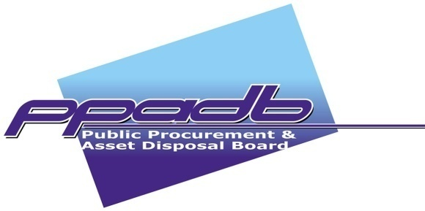
WELCOME REMARKS BY THE PPADB’S EXECUTIVE CHAIRPERSON

BRIDGET POPPY JOHN
AT THE BOS ISO 9001: 2015 CERTIFICATION HANDOVER CEREMONY

GICC

3rd NOVEMBER 2017

Director of Ceremony
Deputy Permanent Secretary to the President,
Managing Director Botswana Bureau of Standards
Permanent Secretaries and Chief Executive Officers here present
Respective MTC and DATC Chairpersons
The Board and Staff of PPADB
Members of the Media
Ladies and gentlemen

Good afternoon.

- It is my pleasure this afternoon to welcome you to this ceremony where we receive with elation the ISO 9001:2015 certification from the Botswana Bureau of Standards (BOBS).
2. Ladies and gentlemen, the certification of the PPADB Quality Management System by BOBS is a clear testament of hard work, consistency, and commitment by the Board, Management and Staff of PPADB to improve the quality of the services we provide and to enhance customer satisfaction.
3. Director of Ceremony, PPADB was first certified on the 15th November 2013 against ISO 9001:2008 Quality Management System standard by Botswana Bureau of Standards (BOBS), and thereafter on the 4th November 2016 after expiry of the initial certification which was valid for three (3) years. The re-certification in November 2016 included the PPADB Francistown Office which was opened in January 2016.
4. Ladies and gentlemen, the International Organization for Standardization (ISO) released a new version of the ISO 9001 standard in September 2015 and Organizations implementing ISO 9001:2008 were given up to September 2018 to have transitioned to the new standard. In response to this development, PPADB developed and implemented a transition plan to align the QMS to the requirements of ISO 9001:2015 and thereafter an application to BOBS for certification to the new standard was made. In June 2017, BOBS conducted rigorous third party audits on the PPADB QMS culminating in the award of certification after establishing that PPADB QMS was in conformance to ISO 9001:2015

5. Director of Ceremony, We are here today to celebrate this wonderful achievement as PPADB is the first organization in Botswana to have successfully transitioned and one of the first three (3) within the country to be certified on the new Standard.
6. Ladies and Gentlemen, the Quality Management System has allowed PPADB to document its processes for service provision, this ensure that there is consistency on how we serve our customers. Further, as we provide services to our customers, we are able to generate sufficient documented information that facilitates auditing of the System. It is through theses audits that we are able to demonstrate conformance to all applicable requirements – these include legal, customer and ISO 9001 requirements.
7. Director of Ceremony, PPADB has demonstrated through the implementation of a QMS that it is committed to the continuous improvement of the public procurement and asset disposal system. The QMS places an obligation on the Organization to constantly interact with all stakeholders and solicit feedback from them on how they perceive PPADB service provision. The constructive feedback received from all relevant stakeholders assist in directing the Organization to areas where it can improve.
8. Ladies and gentleman, our aspiration is to become a center of excellence in public procurement and asset disposal. The QMS therefore, is used together with other business tools employed by the Organization to make this a reality. We are cognizant of the fact that achieving certification is easier compared to maintaining it and are therefore prepared to work harder going forward to ensure that public procurement facilitates economic development in Botswana.

I welcome you to this ceremony.
Pula! Pula! Pula! Pula! Pula! Pula

